Lab Final

Software Testing

Abdullah Iqbal

FA17-BSE-030

**CODE:**

import io.github.bonigarcia.wdm.config.DriverManagerType;  
import io.github.bonigarcia.wdm.managers.ChromeDriverManager;  
import org.junit.jupiter.api.Test;  
import org.openqa.selenium.By;  
import org.openqa.selenium.WebDriver;  
import org.openqa.selenium.chrome.ChromeDriver;  
  
import java.util.concurrent.TimeUnit;  
  
import static org.openqa.selenium.devtools.browser.Browser.*close*;  
//FA17-BSE-030  
//ABDULLAH IQBAL  
  
public class test {  
  
 WebDriver w;  
  
 String Main_url = "https://pay.ebay.com/rgxo?action=view&sessionid=1121622122";  
 String check_url;  
  
 public void startWebDriver(){  
 ChromeDriverManager.*getInstance*(DriverManagerType.*CHROME*).setup();  
 this.w = new ChromeDriver();  
  
 }  
  
 @Test  
 public void goToEbay(){  
 startWebDriver();  
 w.get("https://www.ebay.com/");  
 w.findElement(By.*xpath*("//*[@id=\"gh-cat\"]")).click();  
 w.findElement(By.*xpath*("//*[@id=\"gh-cat\"]/option[5]")).click();  
 w.findElement(By.*xpath*("//*[@id=\"gh-btn\"]")).click();  
 w.findElement(By.*xpath*("//*[@id=\"s0-26-9-0-1[0]-0-1[0]-0-xCarousel-x-carousel-items\"]/ul/li[1]/a/p")).click();  
  
  
 try {  
 TimeUnit.*SECONDS*.sleep(3);  
 } catch (InterruptedException e) {  
 e.printStackTrace();  
 }  
  
 w.findElement(By.*xpath*("//*[@id=\"s0-26_2-9-0-1[0]-0-1\"]/ul/li[1]/div/div[2]/a/h3/span")).click();  
  
 try {  
 TimeUnit.*SECONDS*.sleep(2);  
 } catch (InterruptedException e) {  
 e.printStackTrace();  
 }  
  
 w.findElement(By.*xpath*("//*[@id=\"binBtn_btn\"]")).click();  
  
 try {  
 TimeUnit.*SECONDS*.sleep(2);  
 } catch (InterruptedException e) {  
 e.printStackTrace();  
 }  
  
 w.findElement(By.*xpath*("//*[@id=\"sbin-gxo-btn\"]")).click();  
  
 try { // for manual captcha  
 TimeUnit.*SECONDS*.sleep(20);  
 } catch (InterruptedException e) {  
 e.printStackTrace();  
 }  
  
 w.findElement(By.*xpath*("//*[@id=\"country\"]")).click();  
 w.findElement(By.*xpath*("//*[@id=\"country\"]/option[151]")).click();  
 w.findElement(By.*xpath*("//*[@id=\"firstName\"]")).sendKeys("abdullah");  
 w.findElement(By.*xpath*("//*[@id=\"lastName\"]")).sendKeys("iqbal");  
 w.findElement(By.*xpath*("/html/body/div[2]/div/div[1]/div[3]/div[1]/div/div[1]/section[2]/div[2]/div/div/div/div[2]/div[1]/form/section/div/div[3]/div[1]/div/div[1]/input")).sendKeys("abc");  
 w.findElement(By.*xpath*("//*[@id=\"addressLine2\"]")).sendKeys("aaa");  
 w.findElement(By.*xpath*("//*[@id=\"city\"]")).sendKeys("Abbottabad");  
 w.findElement(By.*xpath*("//*[@id=\"stateOrProvince\"]")).sendKeys("kpk");  
 w.findElement(By.*xpath*("//*[@id=\"postalCode\"]")).clear();  
 w.findElement(By.*xpath*("//*[@id=\"postalCode\"]")).sendKeys("22010");  
 w.findElement(By.*xpath*("//*[@id=\"email\"]")).sendKeys("iqbalabdullah640@gmail.com");  
 w.findElement(By.*xpath*("//*[@id=\"emailConfirm\"]")).sendKeys("iqbalabdullah640@gmail.com");  
 w.findElement(By.*xpath*("//*[@id=\"phoneNumber\"]")).sendKeys("3409314148");  
 w.findElement(By.*xpath*("//*[@id=\"mainContent\"]/div[1]/div/div[1]/section[2]/div[2]/div/div/div/div[2]/div[1]/form/div/span/div/button")).click();  
  
 try {  
 TimeUnit.*SECONDS*.sleep(2);  
 } catch (InterruptedException e) {  
 e.printStackTrace();  
 }  
  
 this.check_url = w.getCurrentUrl();  
  
 if (check_url.equals(this.Main_url)){  
 System.*out*.println("Passed");  
 }  
  
  
  
  
 }  
  
}

**Screen Shots:**

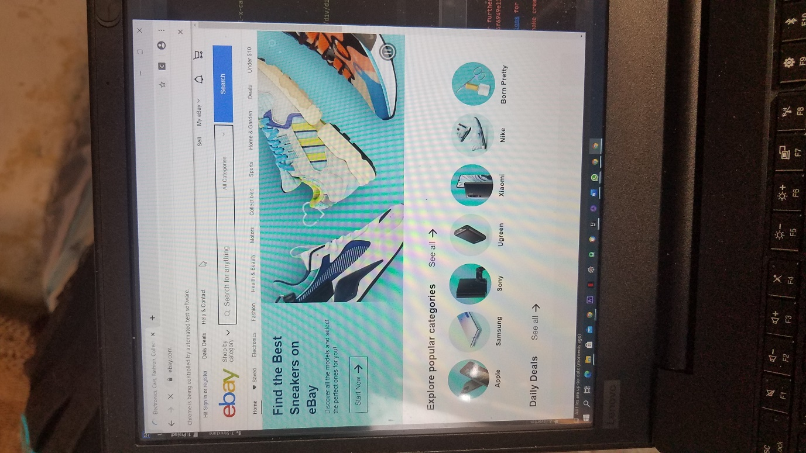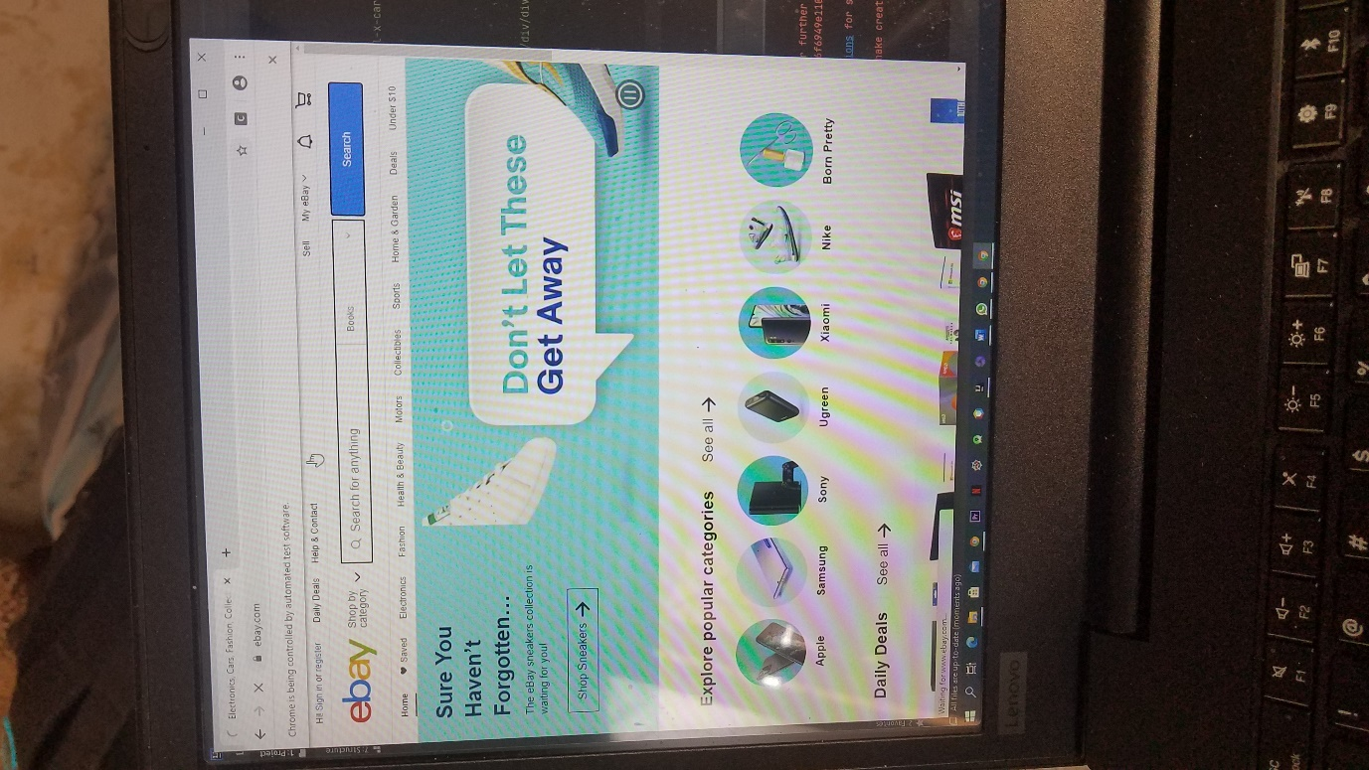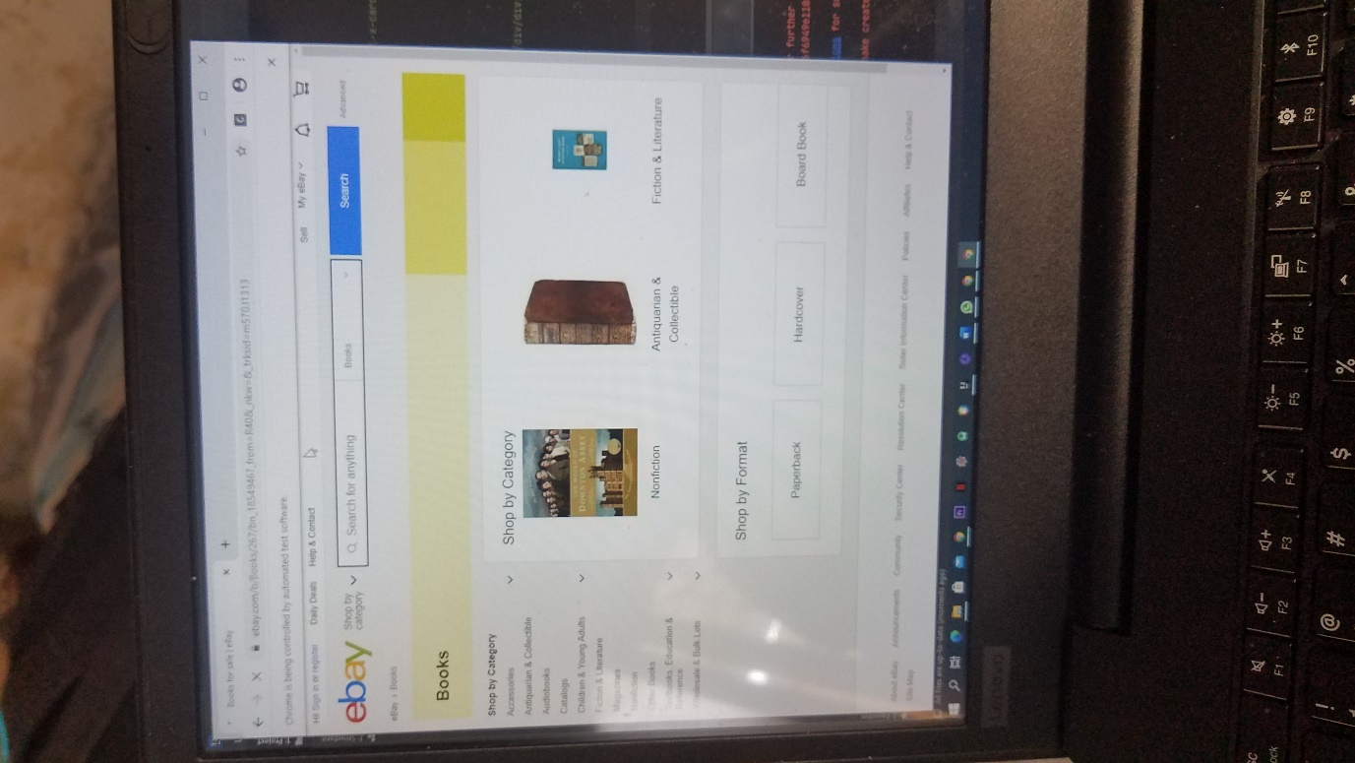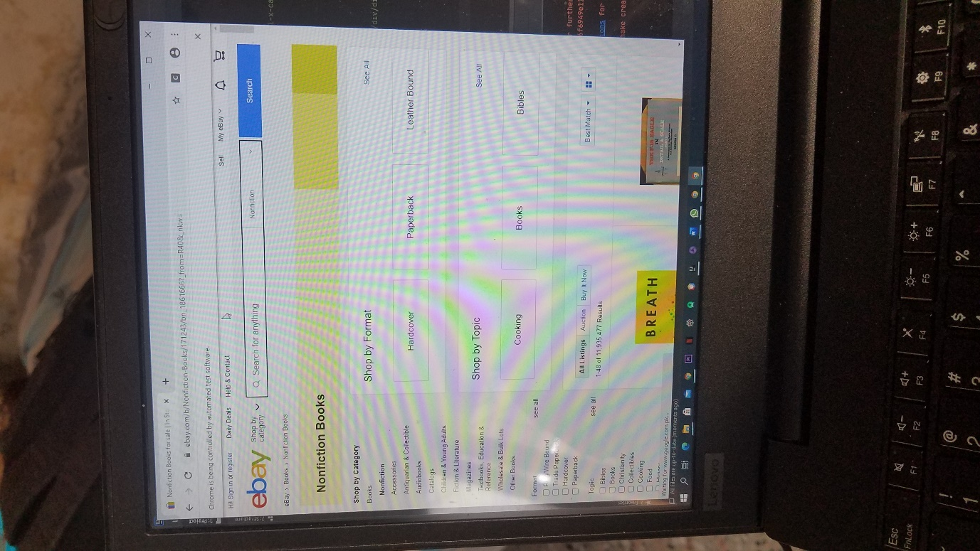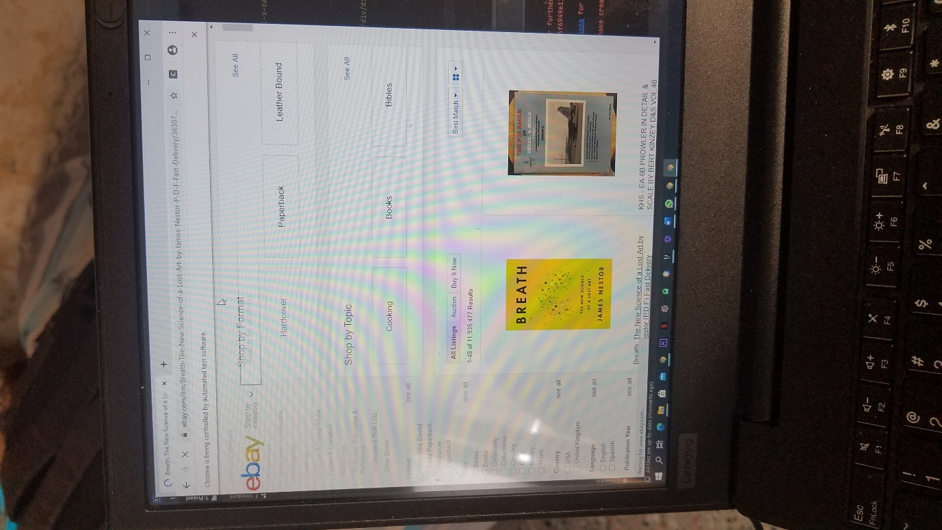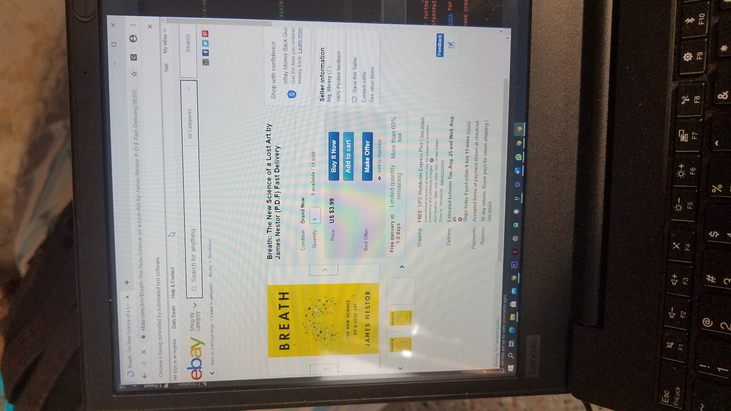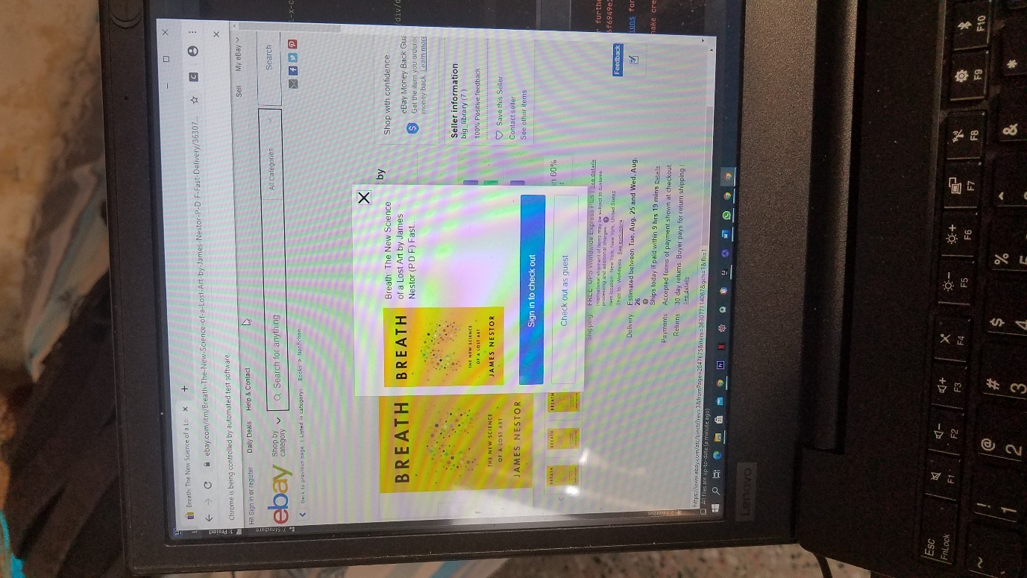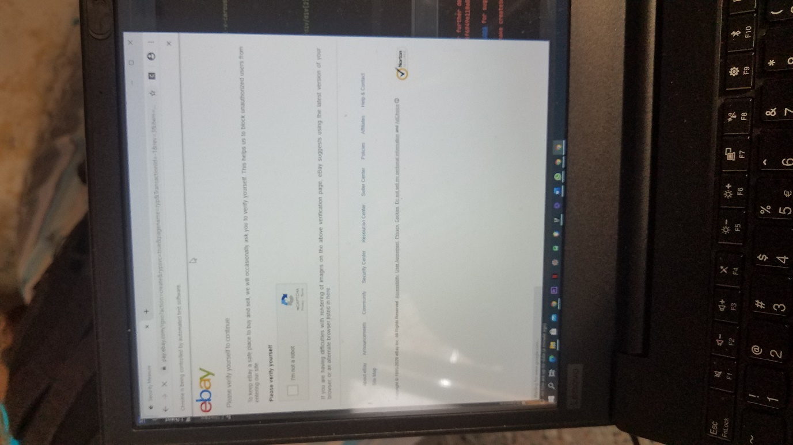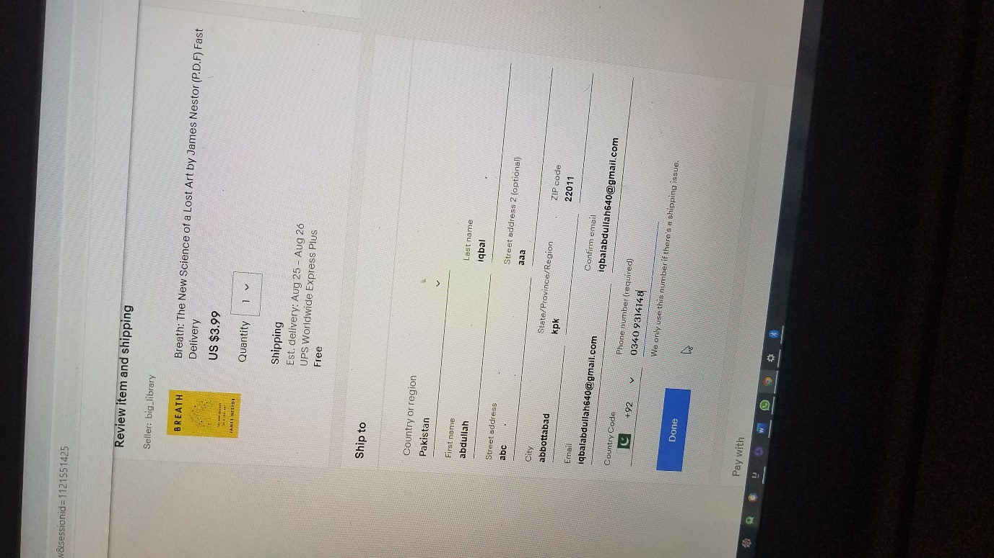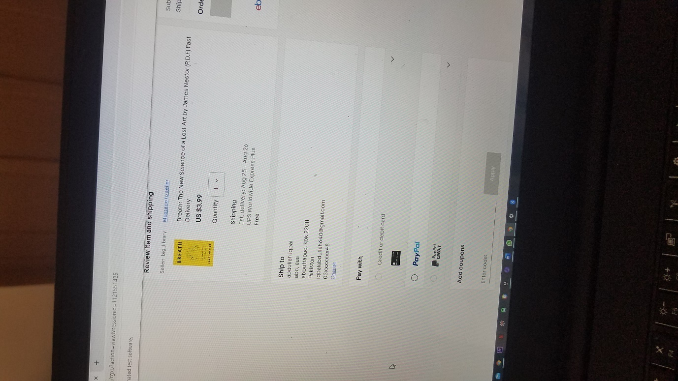

**GITHUB:**

<https://github.com/abdullah098/SoftWare-testing-Lab-Final.git>